MMC AMR Encoder Design

for JASPER-II
ALG. CoolSand tech.

This Document contains proprietary information which is the property of Coolsand Technologies, Inc. and is strictly confidential and shall not be disclosed to others in whole or in part, reproduced, copies, or used as basis for design, manufacturing or sale of apparatus with not the written permission of Coolsand Technologies, Inc..

Revision History
Date | Reason For Changes | Name | Version
2026-11-07 |  | Zouying | V1.00.00

Reviewed and Approved By
Date | Name | Comment | Version
2026-11-07 |  |  | V1.00.00

Contents

MMC AMR Encoder Design 1
for JASPER-II 1
Contents 3
1. Instruction 4
2. Overview 4
3. Main Flow chart 4
4. Main Design 5
4.1 Record state mechine 5
4.2 Encode Flow Chart 6
4.3 Record PCM Data Flow Fhart 6
5. Data Struct and Enum 7
6. Main API Defination 7
MMC_AmrEncOpen ( ) 7
MMC_AmrEncRun ( ) 8
MMC_AmrEncClose ( ) 9

- Instruction
This documentation describes AMR encoder of MMC layer.

- Overview
This program will take pcm data from Jade which will be transferred to Lily, then in the Lily part I will encoder the pcm data using AmrRing Encoder that is the record function , further more there are pause ,resume and stop funtions.

- Main Flow chart
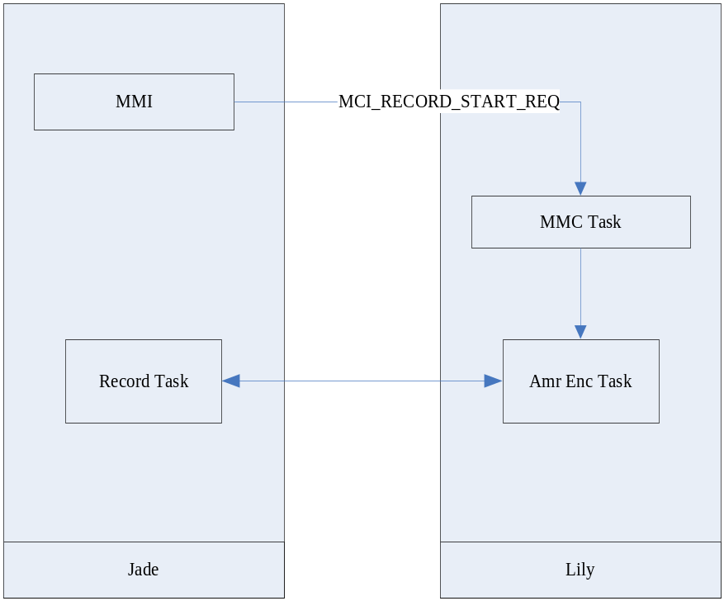

- Main Design

4.1 Record state mechine

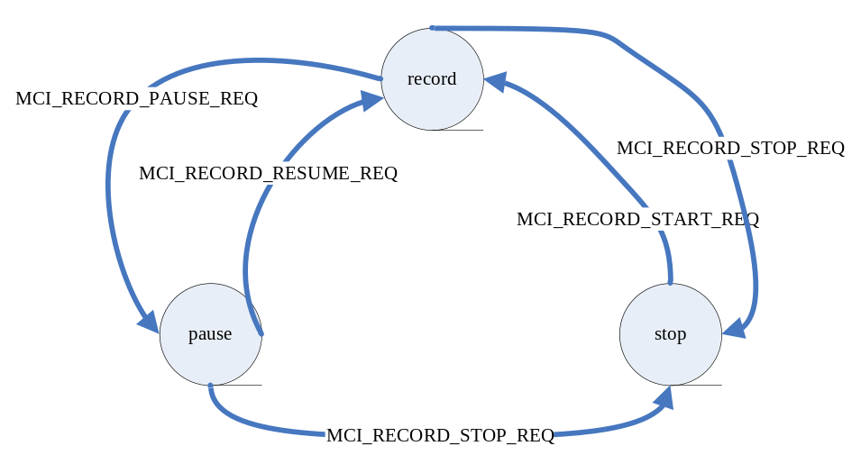

4.2 Encode Flow Chart
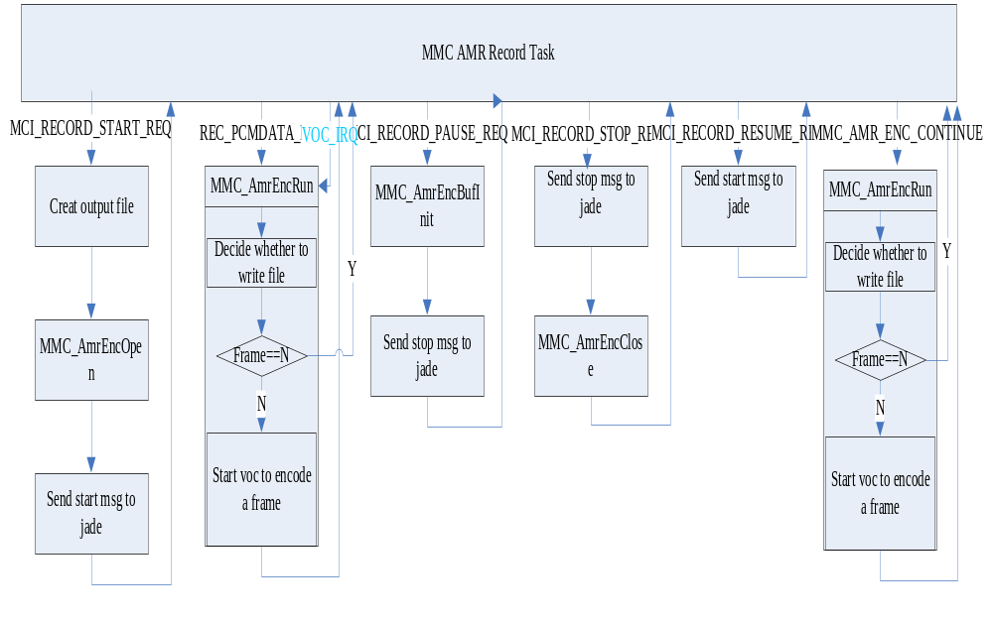

4.3 Record PCM Data Flow Fhart

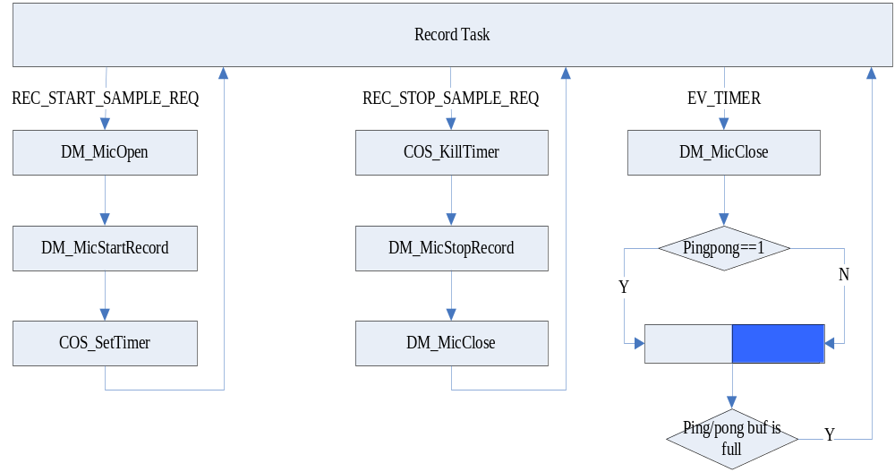
- Data Struct and Enum
typedef struct
{
HANDLE fileHandle; //file handle of record file
INT32 *pingInData; //input buf pointor
INT32 *pingOutData; //output buf pointor
INT32 frame_arm; //flag of encode frame num
INT32 frame_output;//flag of write file frame num
} MMC_AMRENC_IO;//AMR encoder struct

typedef enum
{
NO_ERRO=0,
ERROR_OPENFAIL=-1,
ERROR_WRITEFAIL=-2,
ERROR_AMROPENFAIL=-3,
ERROR_RESUMEFAIL=-4,
ERROR_CloseFAIL=-5

}error_type;//error type

typedef enum
{
Recordstate,
Pausestate,
Stopstate
}RecordState;//state of record

- Main API Defination

MMC_AmrEncOpen ( )
This function do some init work for encoder

error_type MMC_AmrEncOpen(UINT8 * pFileName

,MMC_AMRENC_IO* amr_in)

Parameters

pFileName : the name of encoded file
amr_in: record struct

Return Value
Error type

Remark

Example
The following code fragment shows that how to use this function.
MMC_AMRENC_IO amr_enc;
MMC_AmrEncOpen("gu2.amr",&amr_enc);

MMC_AmrEncRun ( )
This function do the main encode work

error_type MMC_AmrEncRun(MMC_AMRENC_IO* amr_in)

Parameters
amr_in: record struct

Return Value
Error type

Remark

Example
The following code fragment shows that how to use this function.

MMC_AMRENC_IO amr_enc;

MMC_AmrEncRun(&amr_enc);

MMC_AmrEncClose ( )
This function close voc and write remain data to the recorded file

error_type MMC_AmrEncClose(MMC_AMRENC_IO* amr_in)

Parameters
amr_in: record struct

Return Value
Error type

Remark

Example
The following code fragment shows that how to use this function.
MMC_AMRENC_IO amr_enc;

MMC_AmrEncClose(&amr_enc);

